**Project-Report**

**BANK MANAGEMENT SYSTEM**



**Submitted to: Miss Rafia Shaikh**

**By:**

**HUZAIFA MAHMOOD**

**(FA21-BSSE-0079)**

**ANAS AHMED**

**(FA21-BSCS-0092)**

**Date: 27 may 2022**

**Department of Computer Science**

##### Muhammad Ali Jinnah University

22-E Block 6, PECHS, Karachi-Pakistan

**1. Introduction:**

This Bank Management System makes use of C++’s classes and record-keeping features. This system is based on a client’s record information idea. The customer can perform all of the errands here, such as creating a new account, depositing money, withdrawing money, checking balance, viewing all record holders’ details, closing a record, and so on.

**2. Problem Statement:**

Although the basic type of services offered by a bank depends upon the type of bank and the country, services provided usually include: Taking deposits from their customers and issuing current or checking accounts and savings accounts to individuals and business. Extending loans to individuals and business, Cashing cheque. Facilitating money transactions such as wire transfer and cashiers cheque, Consumer & commercial financial advisory services, financial transaction can be performed through many different channels.

**4. Project Description:**

It manages all the transactions like new account entry, deposit as well as withdraw entry, transaction of money for various processes, loan entry, managing bills cash or cheque, etc. Thus, above features of this software will save transaction time and therefore increase the efficiency of the system.

**5. Real Life Application of your project:**

As we can see in the banks around us. The application of bank management system is implemented as the software in the bank now a days for the information of data entry, account status, balance inquiry etc.

**(output snippets):**

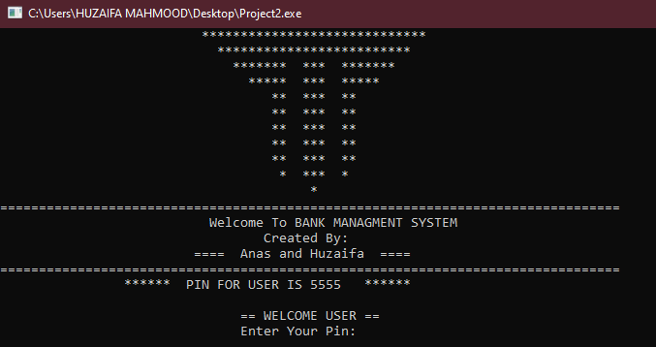

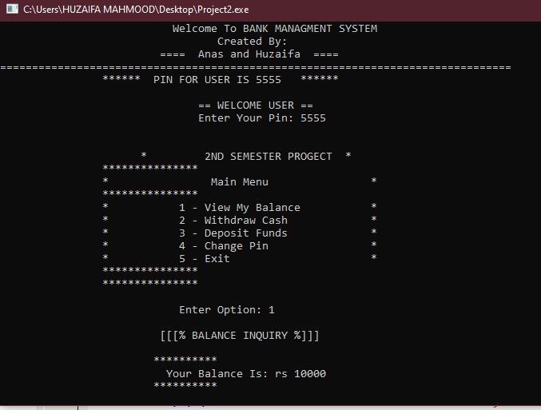

**6. Conclusion:**

The system automates basic banking activities to aid a bank clerk’s day-to-day operations. Additionally, the system’s purpose is to allow for the storage of information for a large number of client accounts, as well as the ability to add, retrieve, and edit information for any account.